**Tutorial 25: Reaction Timer Game – Showing Results Component**

In this tutorial we show the results component when the game ends that will have to score of the users reaction time based on how fast they were able to click the block.

Make sure **Tutorial 24** is complete to be able to move on to this tutorial or clone the [vue3-firebase-course](https://github.com/younggrasshopperza/vue3-firebase-course) repository and go to branch called **Tutorial-24**.

**Step 1:** In the **App.vue** file, import the **Results.vue** component, include the imported file inside the components section. Call the Results component in the template.

Display the component when the **showResults** data property is true. Create a **prop** called **score** inside the **Results** **component** that takes the score data property.

Look at the example below (**Between line 5 and 15**):

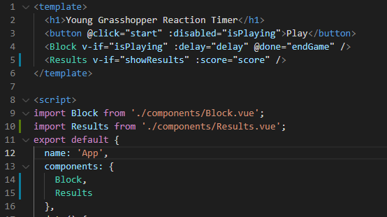

**Step 2:** In the **Results.vue** file, insert the template tags and script tags. Inside the template tag create a paragraph that displays the score.

Create the props property that has a value called score, from the **App.vue** file

Look at the example below (**Between line 1 and 10**):

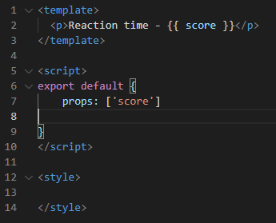

**Output:**

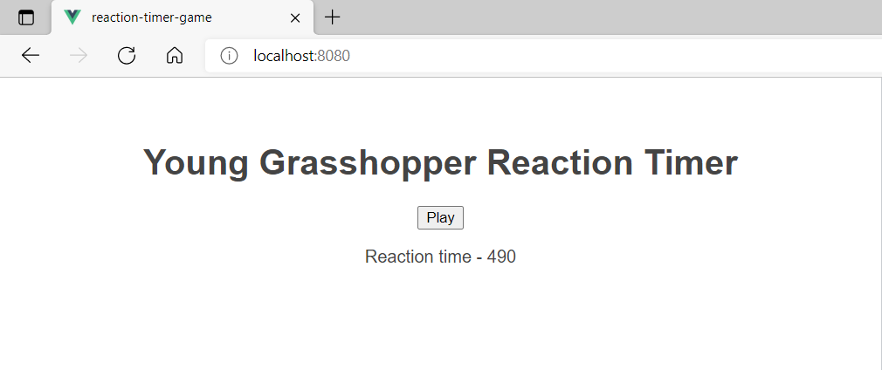

**You can view the code snippets from the** [**vue3-firebase-course**](https://github.com/younggrasshopperza/vue3-firebase-course) **repository under the Tutorial-25 branch**.